下载python源码包<http://www.python.org/getit/>

nginx-1.4.4.tar.gz Python-2.7.6.tgz

解压tar xvf Python-2.7.6.tgz

进入目录 cd Python-2.7.6/

编译 需要几分钟

./configure --prefix=/data/app/python

make

看有几个库没有安装，，，，

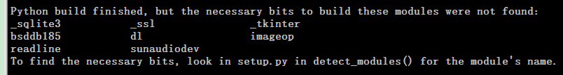

安装几个常用库

_ssl ： openssl <http://www.openssl.org/source/>

安装openssl

tar xvf openssl-1.0.1e.tar.gz

cd openssl-1.0.1e

./config shared --prefix=/data/app/openssl

make

make install

可以删除安装文件

cd ..

rm -rf openssl-1.0.1e

添加环境变量，重新编译python

#C_INCLUDE_PATH=/data/app/openssl/include:$C_INCLUDE_PATH

#export C_INCLUDE_PATH

#LIBPATHS=/data/app/openssl/lib

#LD_LIBRARY_PATH=$LIBPATHS:$LD_LIBRARY_PATH

#export LD_LIBRARY_PATH

#LIBRARY_PATH=$LIBPATHS:$LIBRARY_PATH

#export LIBRARY_PATH

编辑Modules/Setup.dist

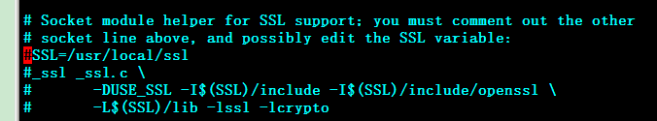

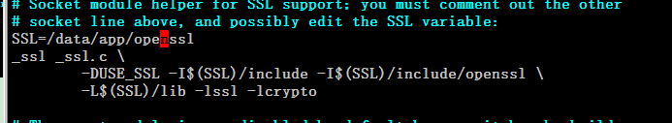

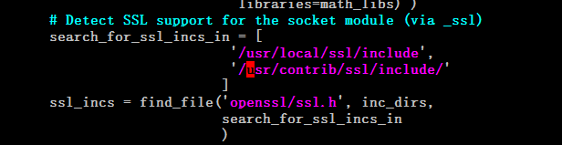

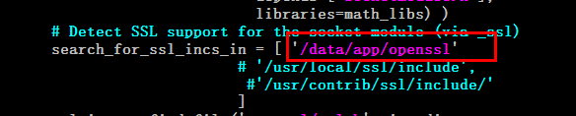

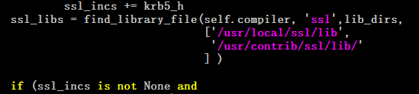

./configure --prefix=/data/app/python

make

Ngnix安装（2个库openssl-1.0.1e.tar.gz pcre-8.34.zip）

mkdir build_nginx

cp ../nginx-1.4.4.tar.gz ../openssl-1.0.1e.tar.gz ../pcre-8.34.zip .

tar xvf nginx-1.4.4.tar.gz

tar xvf openssl-1.0.1e.tar.gz

unzip pcre-8.34.zip

编译

cd nginx-1.4.4/

./configure --with-http_stub_status_module --with-http_ssl_module --with-openssl=../openssl-1.0.1e/ --with-http_gzip_static_module --with-pcre=../pcre-8.34/ --prefix=/data/app/nginx

make

make install

nginx 配置文件

<http://www.cnblogs.com/xiaogangqq123/archive/2011/03/02/1969006.html>